**Redux FireStore**

**Installing Dependencies :**

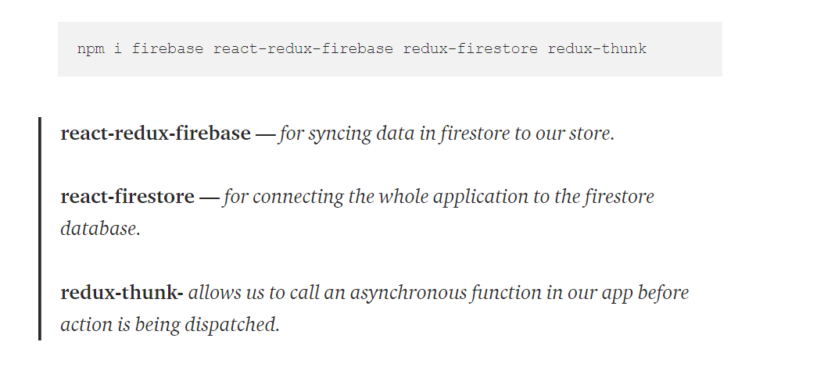

**Setup Firebase Config :**

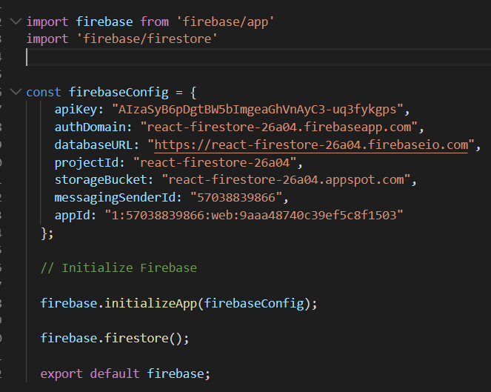

**Making async action creator :**

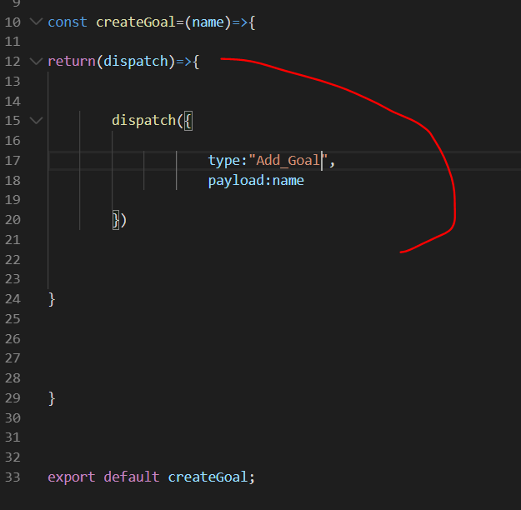

**Import FireStore & fire base :**

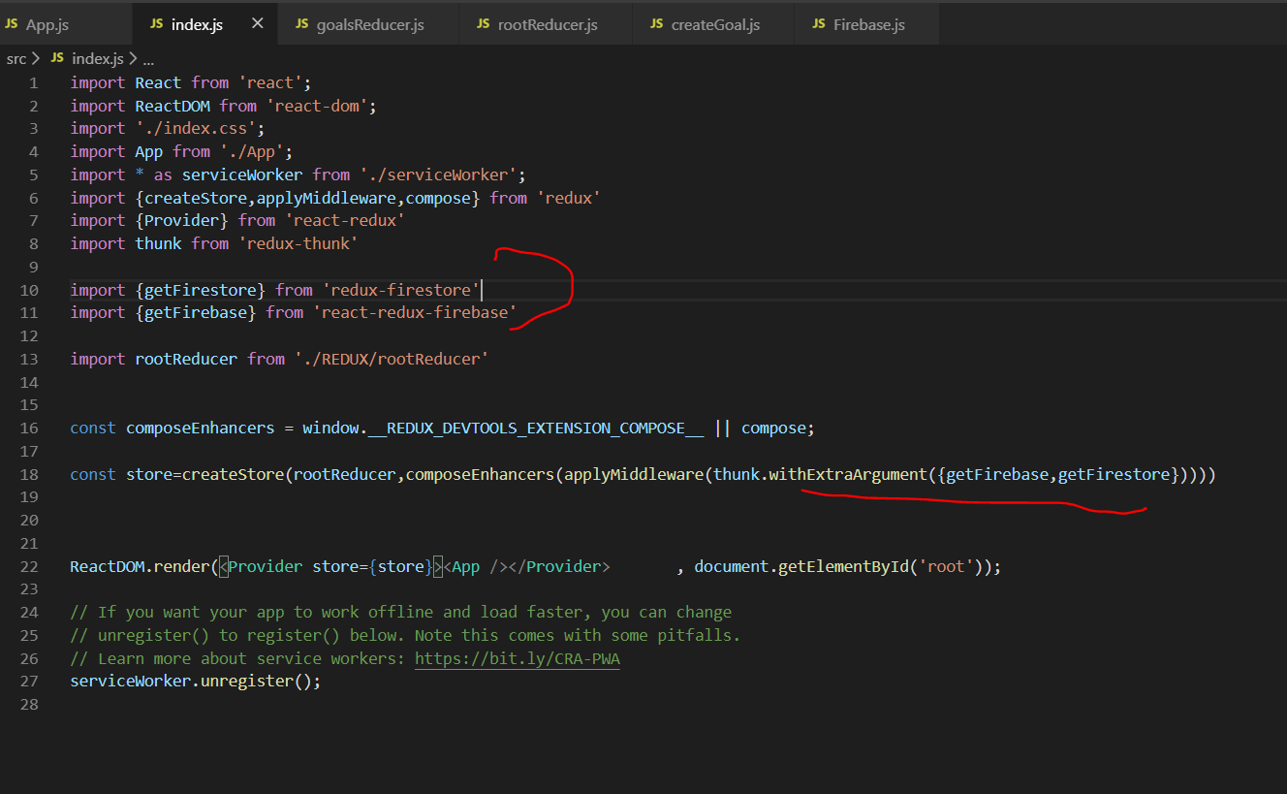

With extra argument (thunk) allows us to use the getFirebase & GetFireStore imports in the dispatch as parameters.

**Use them in thunk :**

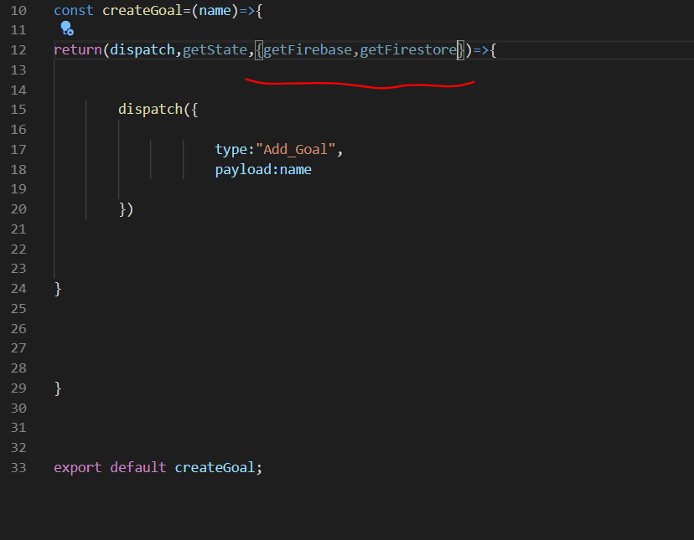

But these two parameters don’t know our project config file so import redux provided functions to give our config file .

**Using Compose to combine all store enhancers :**



**……….**

**Import two more enhancers :**

reduxFireStore   
reactReduxFirebase

**For config file and use them in compose**

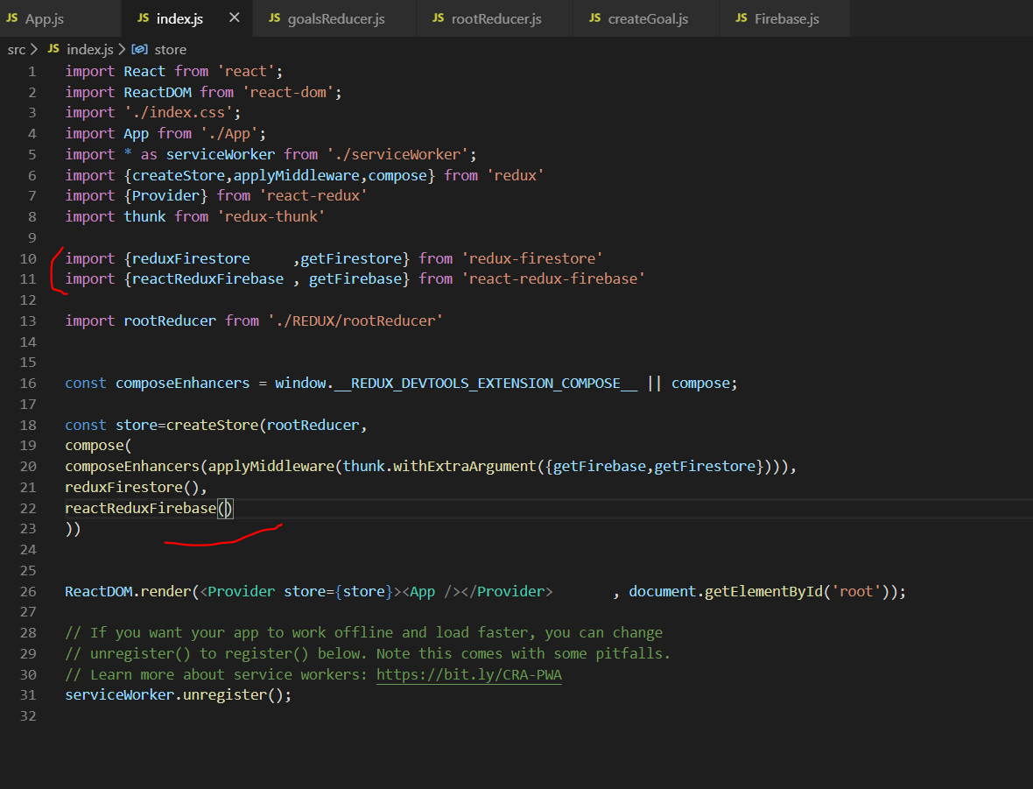

**ADDING CONFIG to both :**

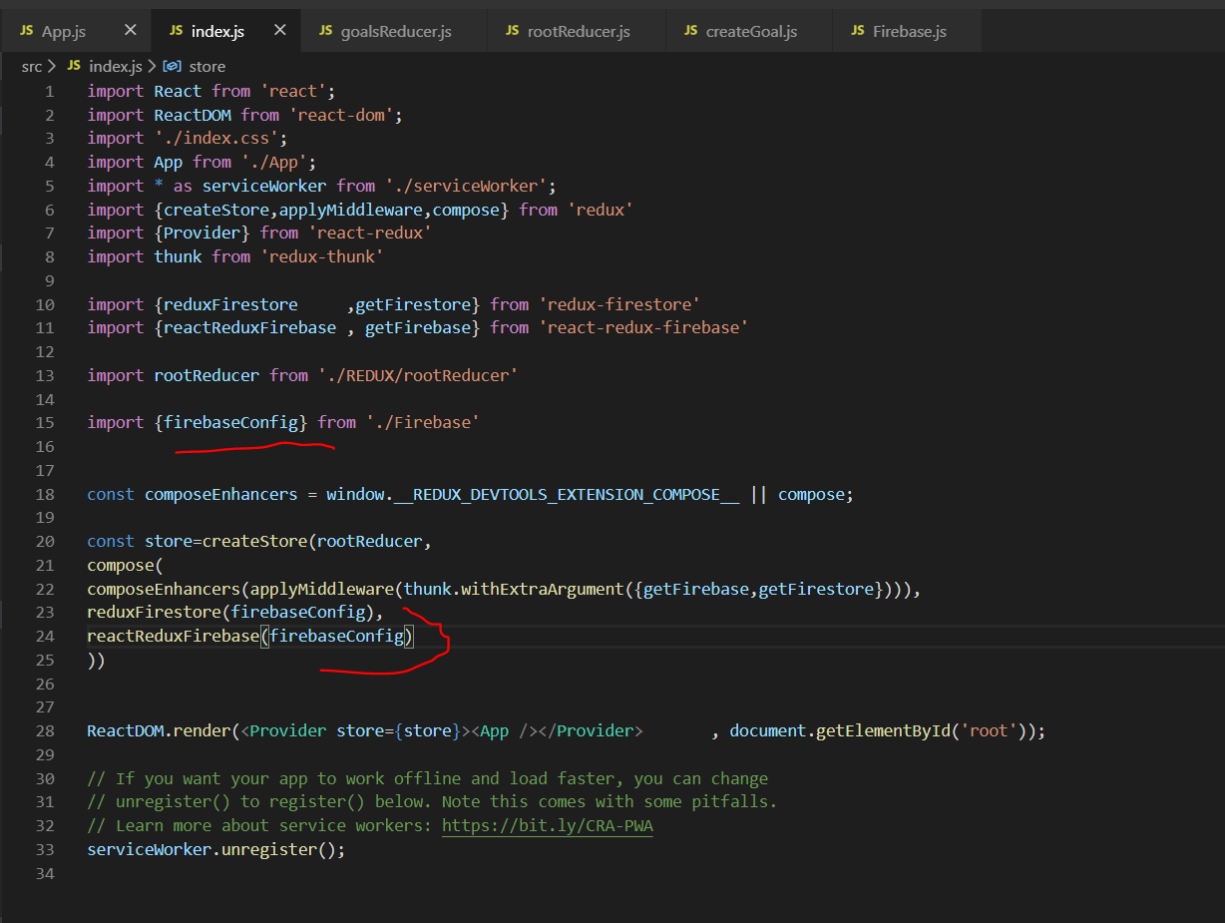

**Adding (dispatching)data to firestore :**

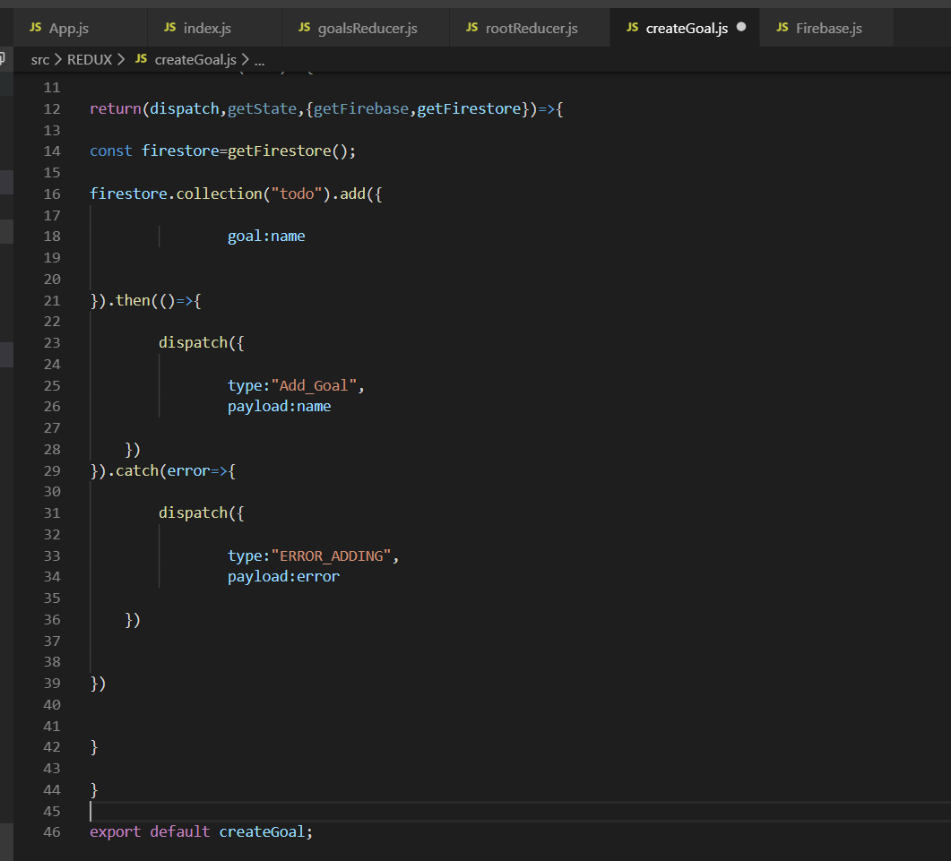

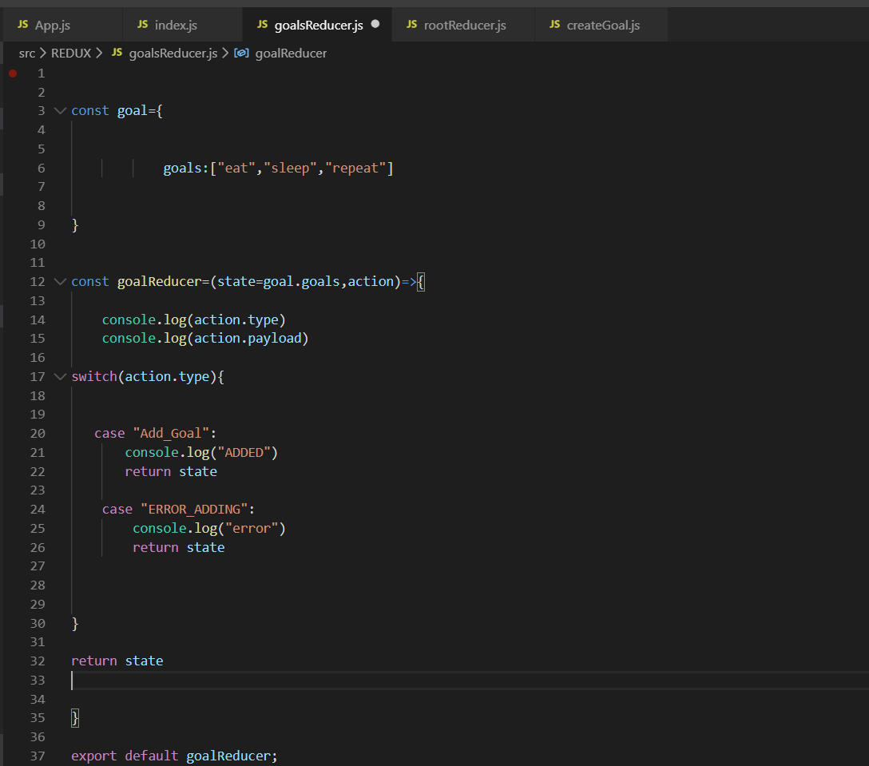

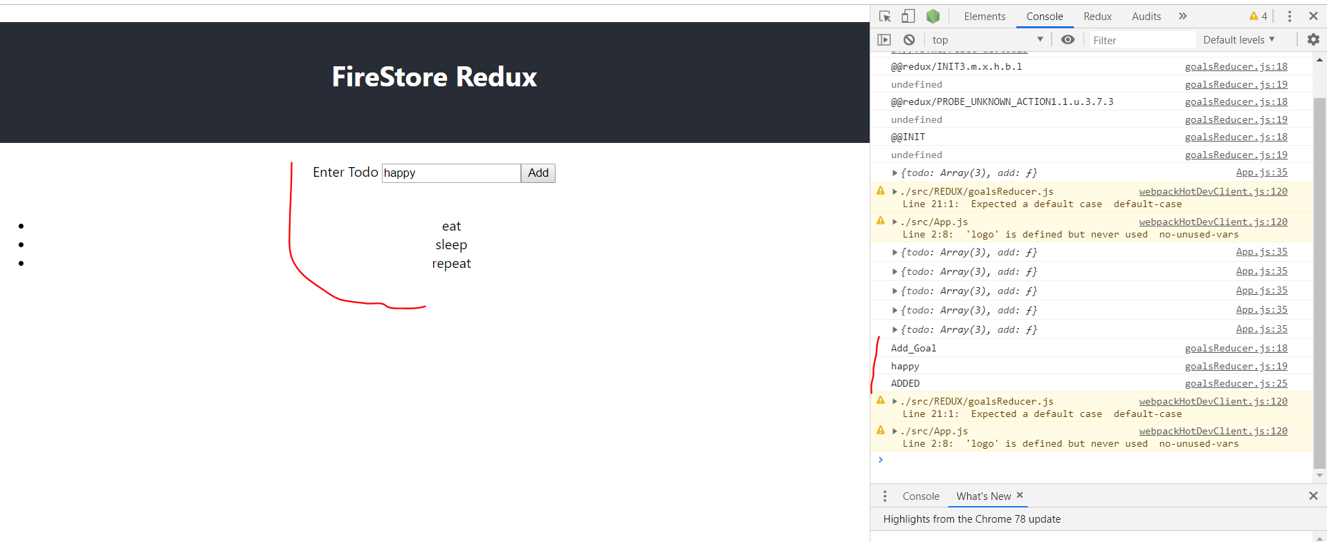

**Getting data from firebase :**

**Get firestore reducer**

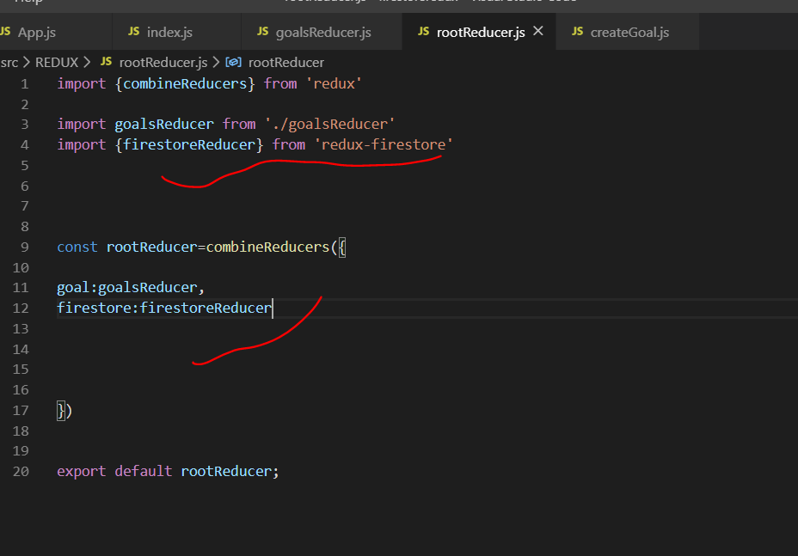

**Get firestore connect**

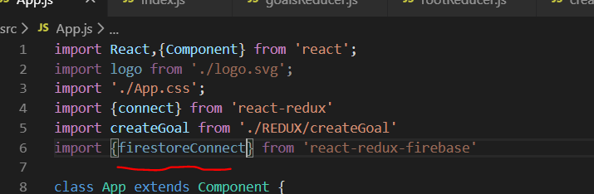

Now u can only use one connect at a time so u have to import a compose enhancer which will make both of them work together.

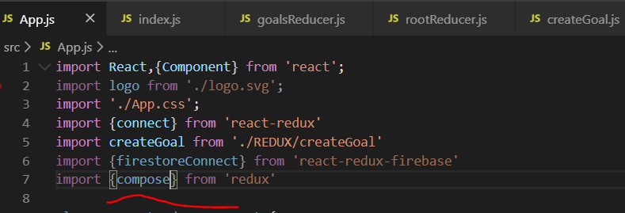

**Now compose both the connect modules.**

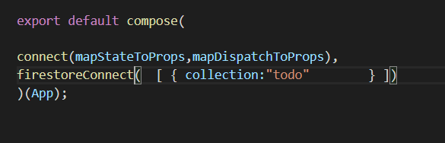

**Check props :**

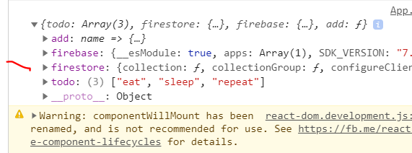

You now have firestore props

**Map the fetched data in props :**

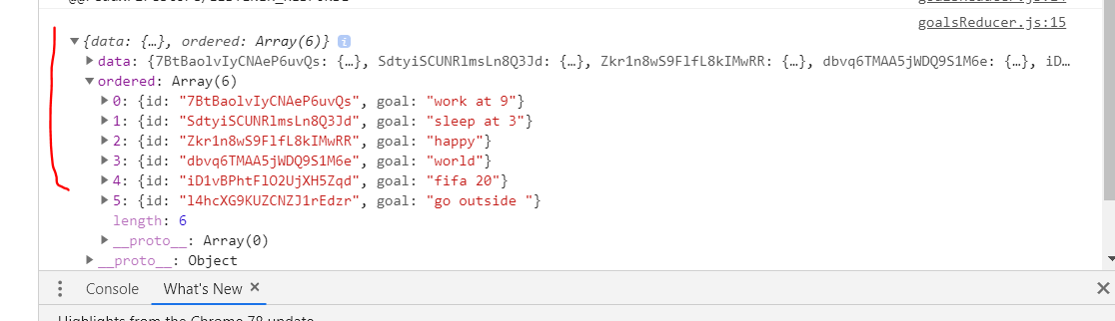

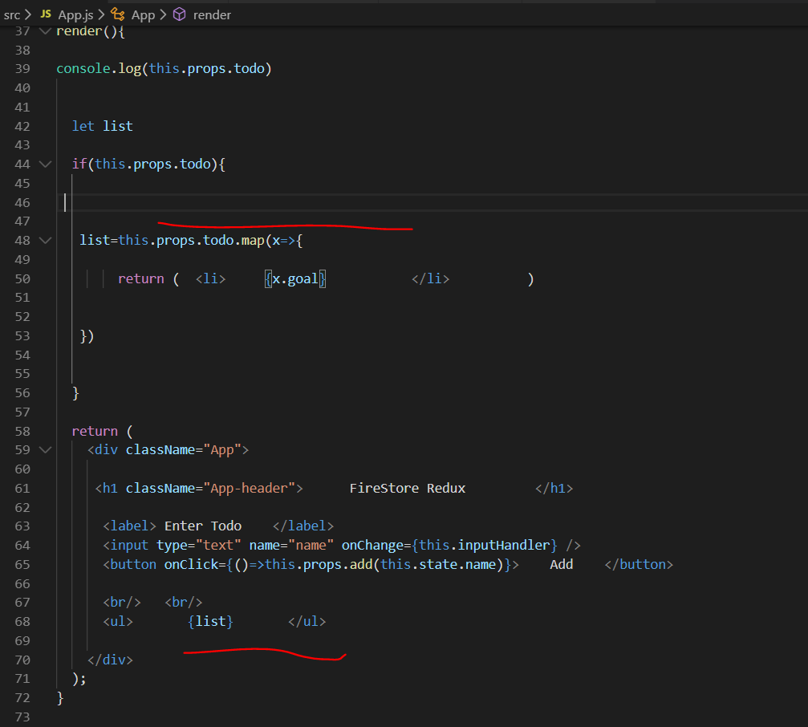

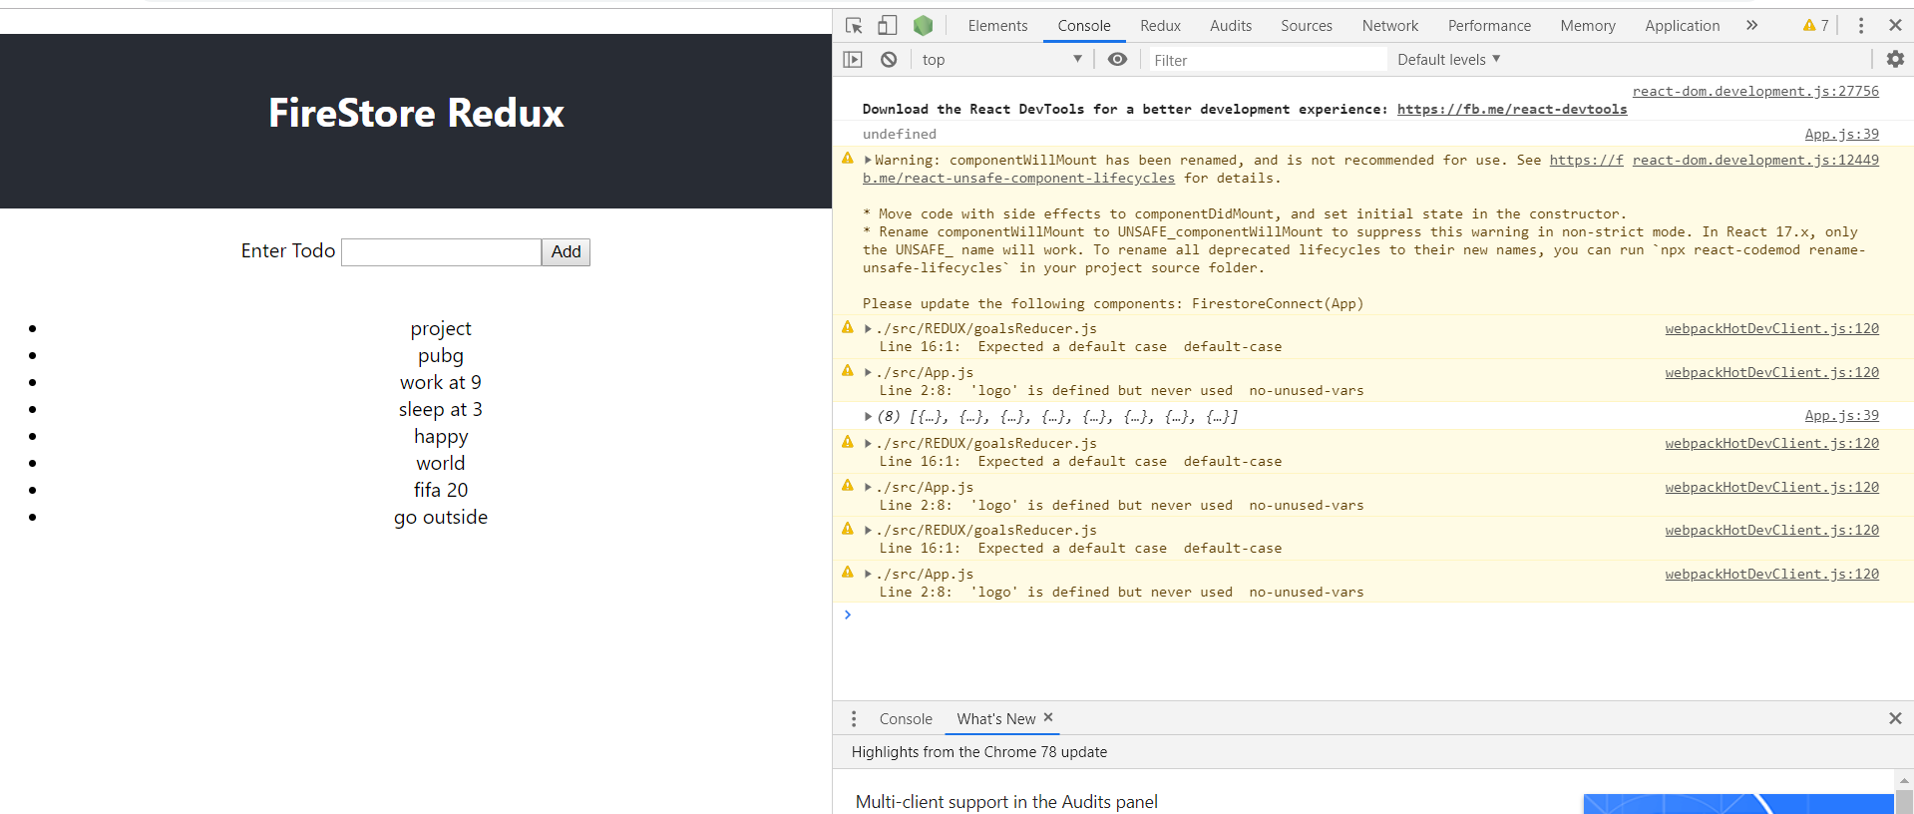

**Deleting Firestore Data :**

Making aysnc action to delete data

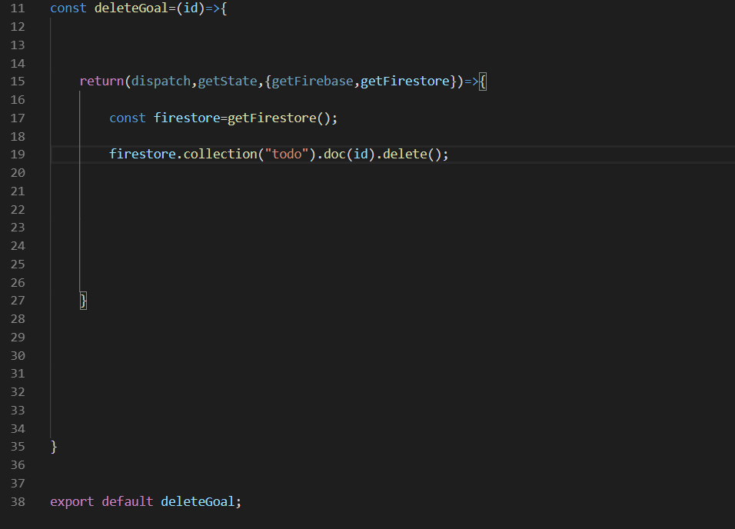

Set up dispatch to props

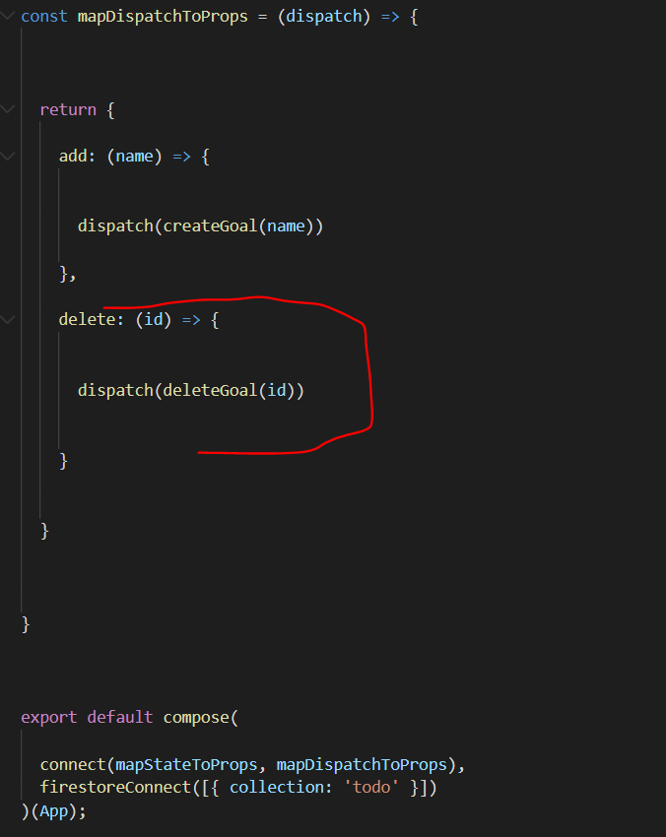

Provide button a function to delete in rendered list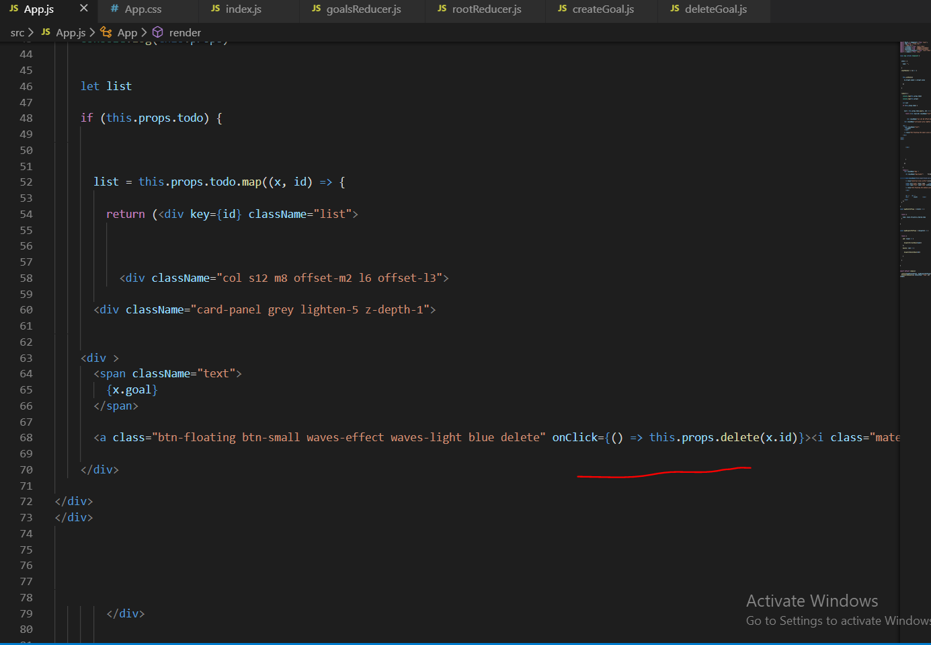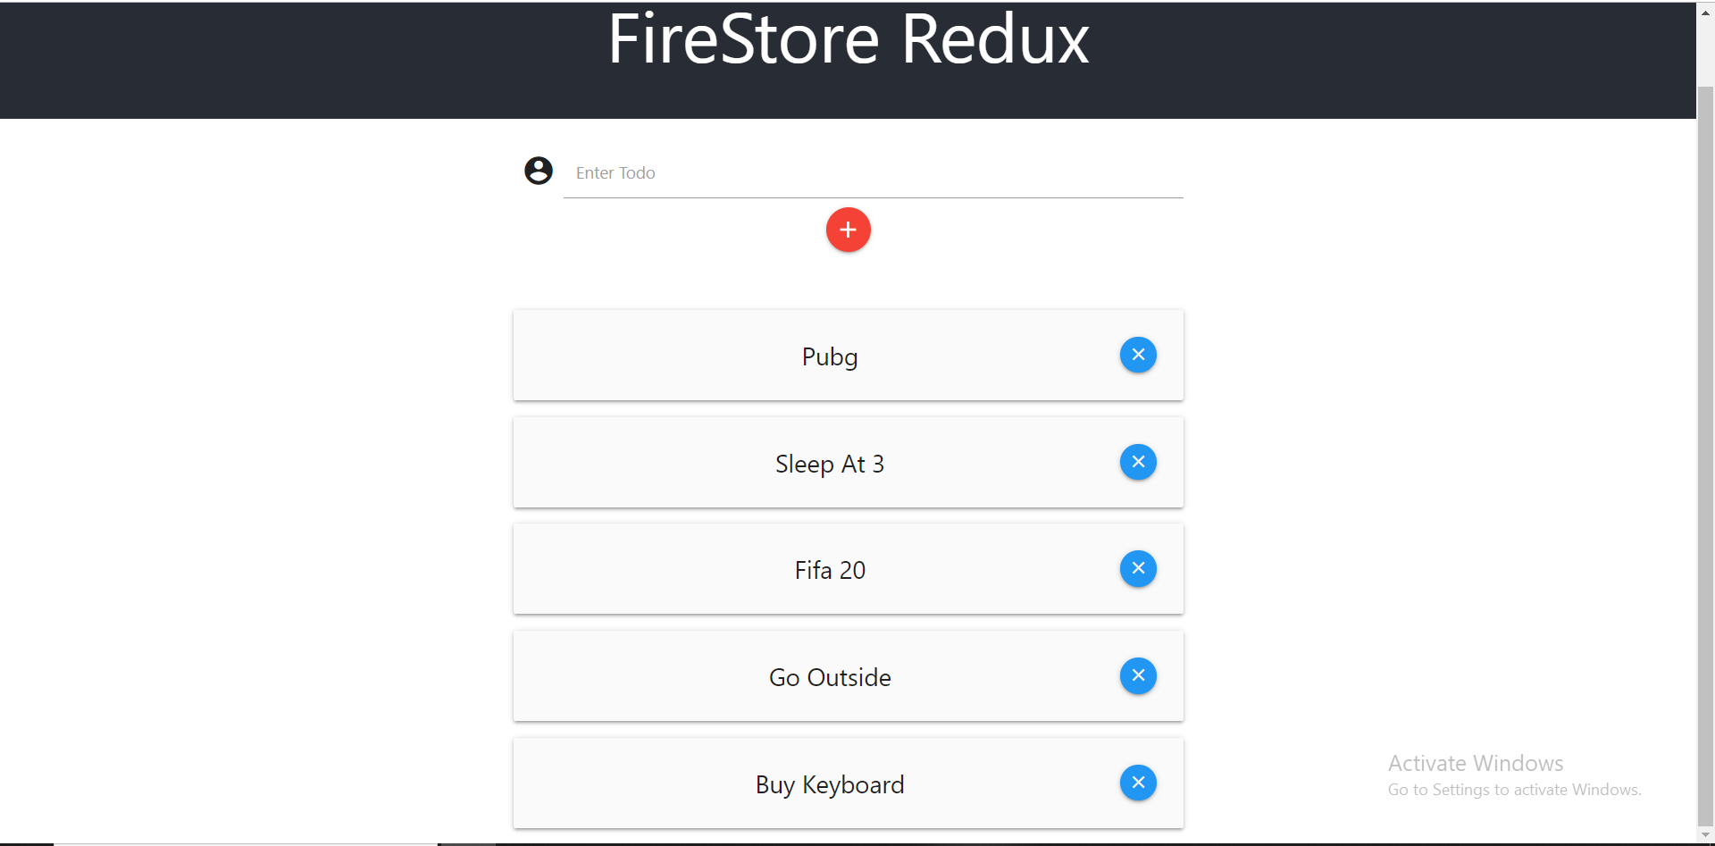

**Updating Data:**

Setting Up update function

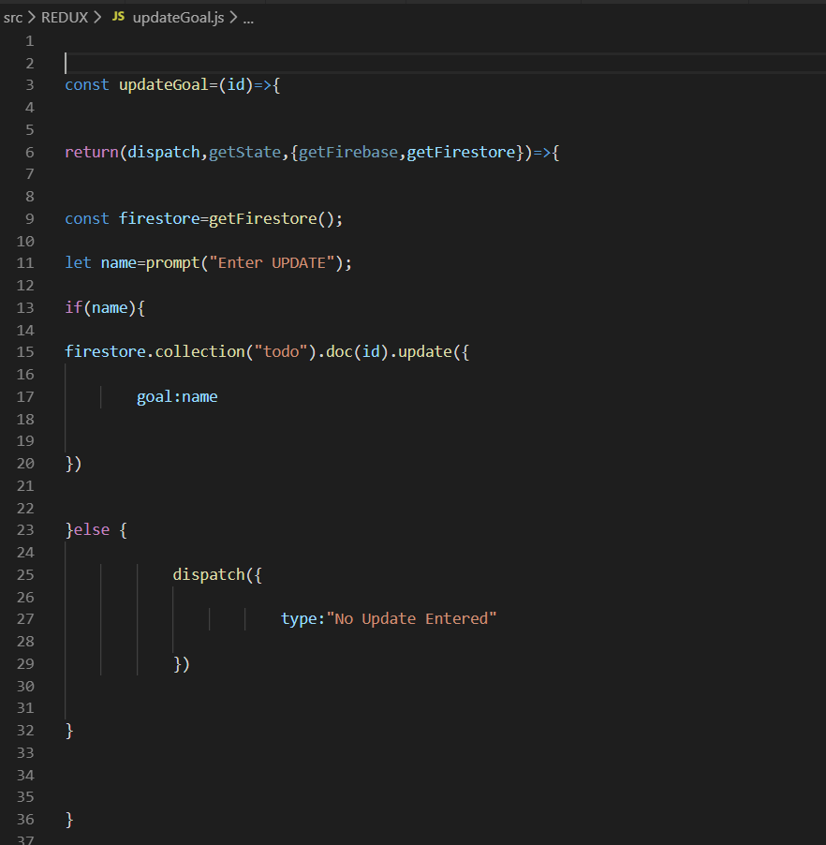

Setting up dispatch

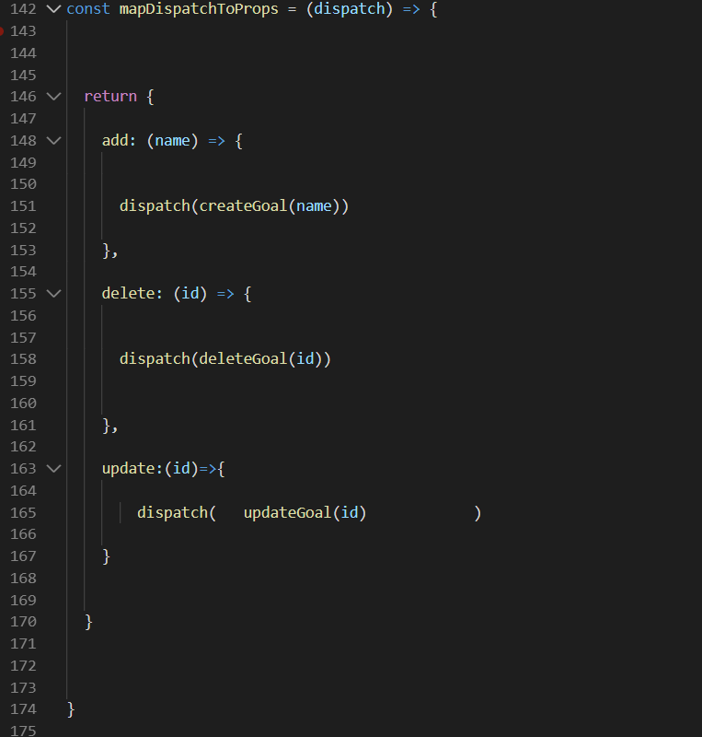

Setting up button and passing id 